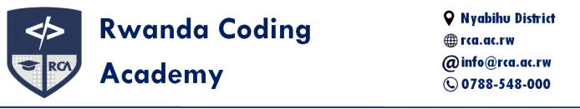

ILead Initiative – Budget Report and Future Plan

- Previous Session Budget Report (Term II)
During the previous session of the ILead initiative, the team conducted outreach and support activities at GS Nanga. The budget and expenditure details are as follows:
Total amount available: 145,000 Frw
Total amount spent: Approximately 120,000 Frw

Breakdown of Expenses:
No | Item | Amount (Frw)
1. | Transport | 30,000
2. | Biscuits | 20,000
3. | Bombo | 5,000
4. | School Fees (77 students × 1,000) | 77,000
5. | Total Used | 120,000

This initiative was made possible by contributions and support from RCA students.

Current Available Budget:

No | Source | Amount (Frw)
1. | Balance from first round contributions | 25,000
2. | New contributions (second term) | 80,000
3. | Total Available for Term III | 105,000

- Planned Budget for Upcoming Session (Term III)
The upcoming session will continue to support the children of GS Nanga, with additional efforts to improve their learning environment and provide necessary supplies. Below is the planned budget:

No | Item | Amount (Frw)
1. | Transport | 30,000
2. | Biscuits and Bombo | 15,000
3. | School Fees (77 students × 1,000) | 77,000
4. | School Bags (77 × 3,000) | 231,000
5. | Shoes (approx. 77 × 12,000) | 93,000
6. | Notebooks (77 × 1,000) | 77,000
7. | Pens (approx. 200 × 77) | 16,000
8. | Total Estimated Budget | 417,000

We aim to not only meet the basic educational needs but also to enhance the learning experience by providing items that support daily school life. The goal is to make sure every child feels cared for and has the tools they need to grow and succeed.
While we already have 105 ,000 Frw collected for this term, there is still a gap to reach the full budget. We are hopeful and open to any kind of support or partnership that may come our way to help us continue this important mission. Every bit of contribution goes a long way in changing the life of a child.
Thank you !

Bank account : 900020040400
Mobile Money: +250 796 060 684
Website: RCA Ilead Initiative
ileadinitiativeteam@gmail.com

